**ACM 114 Homework 2**

1. (70 points) Consider you are working on car rental firm. You have some type of cars that you can offer and you have limited amount for each car. You need to serve your customers using your online robot.

The list of the car belonging to your company with their features as follows:

* Brand: BMW Model: 3.18 Year: 2018 Amount 8 Daily_Price: 140
* Brand: Mercedes Model: A180 Year: 2019 Amount:4 Daily_Price: 120
* Brand: BMW Model: 5.20 Year: 2017 Amount:3 Daily_Price: 210
* Brand: Volkswagen Model: Passat Year: 2014 Amount: 3 Daily_Price: 120

1. Find a way to store each car type in given data in python and implement it correctly.
2. Write a python statements that finds unique Brands within our cars.
3. Write a python statements that ask the user to display the cars in our catalogue according chosen brand from the user:
   * The program should ask the user for entering a **valid option** in **our brand list**.
   * If the user enter a non-valid option as brand, it should continue forever until a valid option or if s/he enter 'exit'
   * If the user input is **'exit'** display nothing for details.

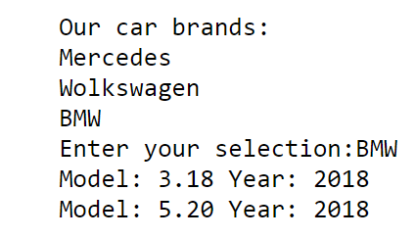

1. Using the solution in **part (c)** let the user choose model of the car and take number of days that s/he want to rent a car if **the car is available** and print the total price for rental.( means that if we have avaible number in our hand) If we do not have enough car in our hand, print **'This selection is not available now'**.
2. (30 points) In XYZ University, upper level math classes are numbered 300 and up. Upper level English classes are numbered 200 and up. Upper level Psychology classes are 400 and up. Create two lists, upper and lower.

Assign each course in classes to the correct list, upper or lower.

classes = ["MATH 150", "PSYCH 111", "PSYCH 313", "PSYCH 412", "MATH 300", "MATH 404", "MATH 206", "ENG 100", "ENG 103", "ENG 201", "PSYCH 508", "ENG 220", "ENG 125", "ENG 124"]

HINT: remember, you can convert some strings to different types!